Course Title

Course Number and Section, number of credits

Semester/Year

CLASS SESSIONS* (REQUIRED)
[Class Day(s)], [Class Start Time] – [Class End Time], [Location]

INSTRUCTOR* (REQUIRED)
[Name], [Degree]
[Phone], [Email]
[Office Location]; [Office Hours]

TEACHING ASSISTANT(S) * [Delete if not applicable.]
[Name] [Email]
[Office Hours]

DESCRIPTION* (REQUIRED)
[Use description in the TU Catalog (https://catalog.tulane.edu/). Course description must be 120 words or less. For new courses, use the course description submitted to the Curriculum Committee. Any changes to the Description must be submitted to Curriculum Committee for review and approval.]

[OPTIONAL: Start a new paragraph if you want to include additional information about how the course is structured, course goals, positionality statement, or anything else you feel is important. Only the first paragraph (max 120 words) will be included in the course catalog.]

PREREQUISITES* (REQUIRED)
[Prerequisites, e.g. SPHL 6020: Foundations of Public Health, or note “none”.]

LEARNING OBJECTIVES* (REQUIRED)
After completing this course, students will be able to do the following:

[List learning objectives. A 3-credit hour course will typically have between 5-8 learning objectives. Learning objectives describe what the student should understand or be able to do as a result of taking your course.]

[Rules for use of Bloom’s Taxonomy verbs differ for writing learning objectives and competencies. There is more flexibility with verb usage. Undergraduate courses focus more on lower-order thinking skills (remembering, understanding, and applying), and graduate courses emphasize higher-order skills (analyzing, evaluating, and creating). The table below offers guidance on the appropriate level of Bloom’s Taxonomy verbs for writing learning objectives for undergraduate and graduate course levels. Levels refers to the course number). SEE EXPLANATION DOCUMENT for more information].

COMPETENCY MAPPING* (REQUIRED)
[Only for courses that are required for a degree, certificate program, or area of specialization. Delete map if not applicable. If you are not sure what competency map should be used for your course, please contact your Program Director or Avery Peterson. SEE EXPLANATION DOCUMENT for more information on signature assessments]

Competency | Signature Assessment [provide a brief, 1- to 3-sentence description of the assessment]

*All sections above are required to appear on the syllabus in the order shown. It is recommended that the sections below remain in order, however instructors may use their discretion to rearrange the sections below.

COURSE STRUCTURE (REQUIRED)
[State how the course will be organized and conducted. This may indicate, for example, whether the class sessions will be lectures, seminars, group work, breakout sections, lab sections; combinations of these, and so on. If the course is organized into units or modules, this section can also describe these units]

MATERIALS, READINGS, RESOURCES (REQUIRED)
Required:
[Required textbook, readings, supplies, and materials, or note “none”]

Recommended:
[Electronic resources, supplementary readings and references or note “none”]

[Some courses require lengthy reading lists each week. In this instance, please add language to the syllabus stating that materials, readings and resources will be listed and accessible in Canvas.

Suggested language: All required readings are listed and accessible in the course Canvas site. It is essential to review the assigned materials prior to each class to engage in discussions and complete assignments effectively.]

ASSESSMENT OF LEARNING (REQUIRED)

Assessment | Weight (or Points)
Participation | XX%
Assignment, Quiz, Exam, Project Paper | XX%
Assignment, Quiz, Exam, Project Paper | XX%
Assignment, Quiz, Exam, Project Paper | XX%
Assignment, Quiz, Exam, Project Paper | XX%
Total | 100%
[Clearly identify the assessment using the language that appears in your syllabus. For example, Assignment #1: Policy Brief, Midterm Exam, Final Paper: Dataset Analysis.
Grading participation in a graduate-level course can be appropriate if it aligns with the course goals. However, participation grading must be thoughtful, with clear expectations that are clearly noted in the course syllabus. Set clear expectations by defining what “participation” means. For example, contributing to class discussions, asking relevant questions, engaging in group activities. Use a rubric to provide transparency.
Need help with a rubric? Ask ChatGPT. SEE EXPLANATION DOCUMENT for more information]
GRADING POLICY: Student grades will be based on:
[Below is a suggested percentage range for each grade. You may wish to substitute different percentage ranges.]

Grade | Percentage range
A | 94.5 and above
A- | 89.5 – 94.49
B + | 87.5 – 89.49
B | 82.5 – 87.49
B - | 79.5 – 82.49
C | 69.5 – 79.49
F | Below 69.5

Description of Required Assignments, Projects, Discussions, Activities:
[Describe the required course assignments, projects, etc and an explanation of how students will receive feedback on their performance, including rubrics (when appropriate) used for evaluation and grading.

Rubrics are NOT required for quizzes and exams.

Need help with a rubric? Ask ChatGPT. SEE EXPLANATION DOCUMENT for more information]
Examinations:
[If exams are part of the course, a description of the type of exam students will take, the time and place where appropriate.]

Late or missed assignments policy:
[Personalize – at the discretion of the instructor]

ATTENDANCE POLICY (REQUIRED)

[Personalize your class attendance policy based on the SPHTM attendance policy for residential and online courses shown below]

Graduate Courses – IN-PERSON

Class attendance is a critical component of learning, and students are expected to attend and participate fully in all scheduled class meetings and activities. Attendance policy is established by the instructor for a given course and is stated in the syllabus. It is up to the instructor to determine whether the student can make up missed quizzes, examinations or other exercises, and grades may be adjusted accordingly. Students are responsible for notifying instructors and the Office of Student Experience about significant absences that result from serious illnesses, injuries, or critical personal problems. Course instructors must clearly state expectations for class participation in the syllabus. Students experiencing barriers to meeting attendance requirements due to disabilities are encouraged to register with the Goldman Center for Student Accessibility to discuss accommodation and to make the necessary arrangements with their Instructor.

(IN-PERSON COURES: By University policy, you do not have to record your classes nor allow any students to attend remotely. You may want to describe your policy so that your students are aware of what they are and are not allowed to do.)

Graduate Courses - Online
Success in online courses is dependent on active participation and engagement throughout the course. Students are required to complete all assignments by the due date. Live sessions in online learning create an interactive and effective learning environment. There may be some live, synchronous sessions that students are expected to attend during which class assignments are competed for a grade. The dates for these sessions are XXX. It is the responsibility of the student to notify the instructor in advance if unable to attend to discuss alternative assignment options. For all other live sessions, attendance will not be graded, however you are responsible for all the content covered. All live sessions are recorded.

ADA/ACCESSIBILITY STATMENT (REQUIRED, as written)
Tulane University is committed to offering classes that are accessible. If you anticipate or encounter disability-related barriers in a course, please contact the Goldman Center for Student Accessibility to establish reasonable accommodations. If approved by Goldman, make arrangements with me as soon as possible to discuss your accommodation so that they may be implemented in a timely fashion. I will never ask for medical documentation from you to support potential accommodation needs. Goldman Center contact information: Email: goldman@tulane.edu; Phone (504) 862-8433; Website: https://accessibility.tulane.edu/.

STUDENT CODE OF ACADEMIC CONDUCT (REQUIRED)

Students are required to adhere to the Unified Code of Graduate Student Academic Conduct, available online at:

https://ogps.tulane.edu/sites/default/files/Unified%20Code%20of%20Graduate%20Student%20Academic%20Conduct%20-%202024%20Final%20(1).pdf

Each student enrolled in the School of Public Health and Tropical Medicine has the responsibility to read, understand and follow the code of academic conduct. Lack of knowledge of code or its application does not constitute an excuse for non-compliance. Tulane University expects and requires behavior compatible with its high standards of scholarship. By accepting admission to the university, a student accepts its regulations and acknowledges the right of the university to take disciplinary action.

[OPTIONAL: You may wish to include guidance on individual work such as: Unless I indicate differently on instructions, all assignments and exams are to be completed individually and without any study aid, including textbooks, class notes, or online sites. If you have any question about whether a resource is acceptable, you must ask the instructor rather than assume.]

[REQUIRED: Include a statement that addresses the use of ChatGPT or other AI tools specifically. State your level of tolerance with the tools. If the use of these tools is permitted, you should explicitly state that students may not submit work generated by AI programs as their own and that all such work should be cited accordingly.]

[OPTIONAL: You may wish to include a statement about the use of websites that contain course content (e.g., Chegg). Educational web sites may contain study guides for specific courses offered by Tulane University. While these sites can be useful learning tools, they should not contain information taken directly from Tulane courses. Tulane University considers lecture slides, recordings, videos, handouts, materials on Canvas, assignments, quizzes, and test questions to be proprietary. Web sites that offer these proprietary materials should be reported to the course instructor(s) and/or to the Dean’s office. The use of unauthorized web sites that contain Tulane University’s proprietary educational materials is considered a violation of the school’s student code of academic conduct.]

WELCOMING COMMUNITY STATEMENT (REQUIRED)

[The following statement can be used verbatim. We recommend that you personalize it to be relevant to your style of teaching, your class structure and your discipline.]

Tulane’s core value of “welcoming community” means that we cultivate classrooms and other learning spaces where students, faculty, and staff can thrive and reach their full potential no matter their backgrounds, experiences, or perspectives. In this classroom, we empower you to participate in building this supportive culture and climate for every member of our community, which requires practicing cultural humility and perspective-taking with people who may have divergent or similar viewpoints. Please be familiar and mindful of our Student Handbook Code of Conduct policies and Tulane’s Nondiscrimination Statement.

RELIGIOUS ACCOMODATION POLICY (REQUIRED)
Per Tulane’s religious accommodation policy as stated at the bottom of Tulane’s academic calendar, I will make every reasonable effort to ensure that students are able to observe religious holidays without jeopardizing their ability to fulfill their academic obligations. Excused absences do not relieve the student from the responsibility for any course work required during the period of absence. Students should notify me within the first two weeks of the semester about their intent to observe any holidays that fall on a class day or on the day of the final exam.

TITLE IX (REQUIRED)
Tulane University recognizes the inherent dignity of all individuals and promotes respect for all people. As such, Tulane is committed to providing an environment free of all forms of discrimination including sexual and gender-based discrimination, harassment, and violence like sexual assault, intimate partner violence, and stalking. If you (or someone you know) has experienced or is experiencing these types of behaviors, know that you are not alone. Resources and support are available: you can learn more at allin.tulane.edu.
Disclosures of gender-based discrimination
In order to comply with the requirements of Title IX of the Education Amendments of 1972, Tulane University requires all faculty members to report incidents of gender-based discrimination. Please know that if you choose to confide in me, I am required by the university to share your disclosure in a Care Connection to the Office of Case Management and Victim Support Services to be sure you are connected with all the support the university can offer. The Title IX Coordinator is also notified of these disclosures. You choose whether or not you want to meet with these offices. You can also make a disclosure yourself, including an anonymous report, through the form at tulane.edu/concerns.
Statement on Confidentiality and Privacy
Tulane University is committed to protecting the privacy of all individuals involved in a disclosure of gender-based discrimination. Any and all of your communications on these matters will be treated as either “Confidential” or “Private.”

Confidential | Private
Certain individuals and resources (see list below) are designated as confidential. Individuals and resources designated as confidential will not share any information, except in extreme circumstances involving imminent danger to one’s self or others, with the Office of Case Management and Victim Services, the Title IX Coordinator, or local law enforcement without the express permission of the disclosing party.  - Counseling & Psychological Services (CAPS) | (504) 314-2277  - The Line (24/7) | (504) 264-6074  - Student Health Center | (504) 865-5255  - Sexual Aggression Peer Hotline and Education (SAPHE) | (504) 654-9543 | Private resources means that information related to a disclosure of gender-based discrimination may be shared with key staff members of the University to assist in the review, investigation, or resolution of the disclosure or to deliver resources, accommodations, and support services. Information pertinent to the disclosure will be shared with the following Offices:  - Case Management & Victim Support Services | (504) 314-2160 or srss@tulane.edu  - Tulane University Police (TUPD) | Uptown - (504) 865-5911 | Downtown – (504) 988-5531  - Office of University Sexual Misconduct Response and Title IX Administration | (504) 865-5611 or titleix@tulane.edu  - Student Affairs Professional On-Call (24/7) | (504) 920-9900

Title IX Safeguards for Pregnant and Parenting Students
Title IX also provides reasonable protections and support for pregnant and parenting students. Discrimination on the basis of a student’s pregnancy, childbirth, false pregnancy, termination of pregnancy, or recovery from any of the previous conditions is prohibited by Title IX, and Tulane is committed to providing equal access to academic programs and extracurricular activities to students who might be, are, or have been pregnant. If you need support related to a pregnancy or any of the previously listed conditions, visit pregnancy.tulane.edu for more information, including a list of resources. Student who believe that they may have experienced pregnancy discrimination can file a complaint with the Title IX Office by contacting 504-865-5611 or titleix@tulane.eduor visiting the office in Jones Hall 308, filing a report at: https://cm.maxient.com/reportingform.php?TulaneUniv=&layout_id=0

Emergency Preparedness & Response: (REQUIRED)
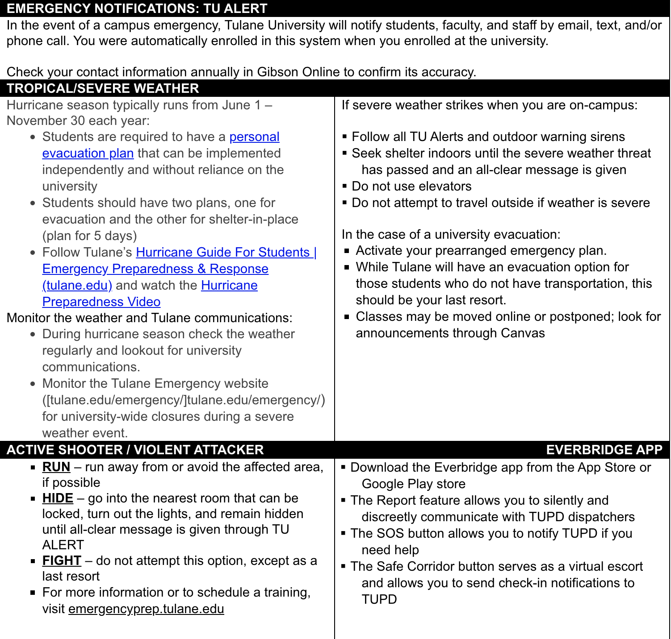
From: Tulane Office of Emergency Preparedness and Response

COURSE SCHEDULE
Session #  Date | Topic | Assignments/Assessments Due  In-class Exercises/Activities | Learning Objective(s)

